The Holy Friendship

of

St. James Episcopal Church
95 Route 2A, Preston, CT 06365

&

Grace Episcopal Church
4 Chapel Hill Road, Yantic, CT 06389

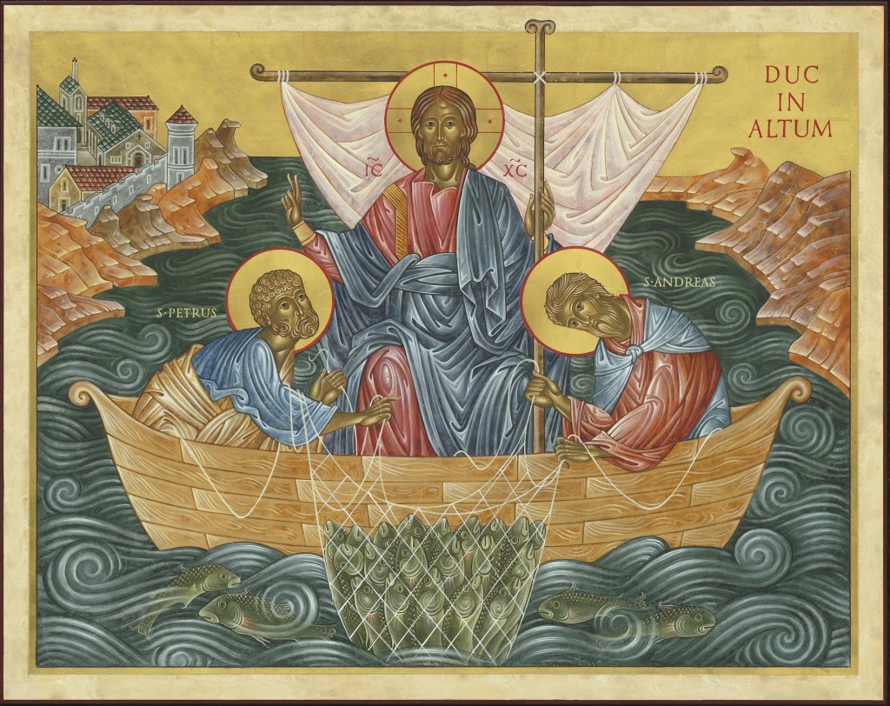
The Fifth Sunday after the Epiphany
February 6, 2022 at 9:00 am

The Reverend David Carter
Musicians
Mike LaFleur, Guitar & Peter Leibert, Concertina

Join us for in-person worship at St. James,
Live stream Sunday’s Worship service on Facebook at: St. James Episcopal Preston
or on Zoom

The Word of God

Welcome
Processional Hymn #390 Praise to the Lord Almighty

Celebrant: Blessed be God; Father, Son, and Holy Spirit
People: And blessed be his kingdom, now and for ever. Amen

Almighty God, to you all hearts are open, all desires known, and from you no secrets are hid: cleanse the thoughts of our hearts by the inspiration of your Holy spirit, that we may perfectly love you, and worthily magnify your holy Name, through Christ our Lord. Amen.

The Gloria
Glory to God in the highest,
and peace to his people on earth. Lord God, heavenly King,
almighty God and Father,
we worship you, we give you thanks,
we praise you for your glory. Lord Jesus Christ, only Son of the Father,
Lord God, Lamb of God, you take away the sin of the world:
have mercy on us; you are seated at the right hand
of the Father:
receive our prayer. For you alone are the Holy One,
you alone are the Lord, you alone are the Most High,
Jesus Christ, with the Holy Spirit,
in the glory of God the Father, Amen.

Celebrant: The Lord be with you. People: And also with you.
Celebrant: Let us pray.

Collect of the Day
Set us free, O God, from the bondage of our sins, and give us the liberty of that abundant life which you have made known to us in your Son our Savior Jesus Christ; who lives and reigns with you, in the unity of the Holy Spirit, one God, now and for ever. Amen.

The Lessons

Isaiah 6:1-8
In the year that King Uzziah died, I saw the Lord sitting on a throne, high and lofty; and the hem of his robe filled the temple. Seraphs were in attendance above him; each had six wings: with two they covered their faces, and with two they covered their feet, and with two they flew. And one called to another and said:
"Holy, holy, holy is the Lord of hosts;
the whole earth is full of his glory."
The pivots on the thresholds shook at the voices of those who called, and the house filled with smoke. And I said: "Woe is me! I am lost, for I am a man of unclean lips, and I live among a people of unclean lips; yet my eyes have seen the King, the Lord of hosts!" Then one of the seraphs flew to me, holding a live coal that had been taken from the altar with a pair of tongs. The seraph touched my mouth with it and said: "Now that this has touched your lips, your guilt has departed and your sin is blotted out." Then I heard the voice of the Lord saying, "Whom shall I send, and who will go for us?" And I said, "Here am I; send me!"

The Word of the Lord.
People: Thanks be to God.

Psalm 138
1 I will give thanks to you, O Lord, with my whole heart; *
before the gods I will sing your praise.
2 I will bow down toward your holy temple
and praise your Name, *
because of your love and faithfulness;
3 For you have glorified your Name *
and your word above all things.
4 When I called, you answered me; *
you increased my strength within me.
5 All the kings of the earth will praise you, O Lord, *
when they have heard the words of your mouth.
6 They will sing of the ways of the Lord, *
that great is the glory of the Lord.
7 Though the Lord be high, he cares for the lowly; *
he perceives the haughty from afar.
8 Though I walk in the midst of trouble, you keep me safe; *
you stretch forth your hand against the fury of my enemies;
your right hand shall save me.
9 The Lord will make good his purpose for me; *
O Lord, your love endures for ever;
do not abandon the works of your hands.

1 Corinthians 15:1-11
I would remind you, brothers and sisters, of the good news that I proclaimed to you, which you in turn received, in which also you stand, through which also you are being saved, if you hold firmly to the message that I proclaimed to you--unless you have come to believe in vain. For I handed on to you as of first importance what I in turn had received: that Christ died for our sins in accordance with the scriptures, and that he was buried, and that he was raised on the third day in accordance with the scriptures, and that he appeared to Cephas, then to the twelve. Then he appeared to more than five hundred brothers and sisters at one time, most of whom are still alive, though some have died. Then he appeared to James, then to all the apostles. Last of all, as to one untimely born, he appeared also to me. For I am the least of the apostles, unfit to be called an apostle, because I persecuted the church of God. But by the grace of God I am what I am, and his grace toward me has not been in vain. On the contrary, I worked harder than any of them--though it was not I, but the grace of God that is with me. Whether then it was I or they, so we proclaim and so you have come to believe.

The Word of the Lord.
People: Thanks be to God.

Sequence Hymn #8 Morning Has Broken

Celebrant: The Holy Gospel of our Lord Jesus Christ, according to Luke.
People: Glory to you, Lord Christ.

Luke 5:1-11
Once while Jesus was standing beside the lake of Gennesaret, and the crowd was pressing in on him to hear the word of God, he saw two boats there at the shore of the lake; the fishermen had gone out of them and were washing their nets. He got into one of the boats, the one belonging to Simon, and asked him to put out a little way from the shore. Then he sat down and taught the crowds from the boat. When he had finished speaking, he said to Simon, "Put out into the deep water and let down your nets for a catch." Simon answered, "Master, we have worked all night long but have caught nothing. Yet if you say so, I will let down the nets." When they had done this, they caught so many fish that their nets were beginning to break. So they signaled their partners in the other boat to come and help them. And they came and filled both boats, so that they began to sink. But when Simon Peter saw it, he fell down at Jesus' knees, saying, "Go away from me, Lord, for I am a sinful man!" For he and all who were with him were amazed at the catch of fish that they had taken; and so also were James and John, sons of Zebedee, who were partners with Simon. Then Jesus said to Simon, "Do not be afraid; from now on you will be catching people." When they had brought their boats to shore, they left everything and followed him.

The Gospel of the Lord People: Praise to you, Lord Christ.

The Homily The Rev. David Carter

~ a short silence will be kept ~

The Nicene Creed
We believe in one God,
the Father, the Almighty,
maker of heaven and earth,
of all that is, seen and unseen.
We believe in one Lord, Jesus Christ,
the only Son of God,
eternally begotten of the Father,
God from God, Light from Light,
true God from true God,
begotten, not made,
of one Being with the Father.
Through him all things were made.
For us and for our salvation
he came down from heaven:
by the power of the Holy Spirit
he became incarnate from the Virgin Mary,
and was made man.
For our sake he was crucified under Pontius Pilate;
he suffered death and was buried.
On the third day he rose again
in accordance with the Scriptures;
he ascended into heaven
and is seated at the right hand of the Father.
He will come again in glory to judge the living and the dead,
and his kingdom will have no end.
We believe in the Holy Spirit, the Lord, the giver of life,
who proceeds from the Father and the Son.
With the Father and the Son he is worshiped and glorified.
He has spoken through the Prophets.
We believe in one holy catholic and apostolic Church.
We acknowledge one baptism for the forgiveness of sins.
We look for the resurrection of the dead,
and the life of the world to come. Amen.

Prayers of the People
Celebrant: God of light and life may our prayers be lifted up to you in this time hope.

Lector: We pray for your church, for our diocese, bishops, clergy and all those who minister the gospel.
Lord, hear our prayers.

Lector: God of wonder and mystery, we pray for all who are coming to faith, all who wonder about faith, and all who are struggling with faith.
Lord, hear our prayers.

Lector: God of abundant love, be our source of joy in proclaiming your Good News to the world.
People: Lord, hear our prayers.

Lector: God of winding ways and straight paths, we pray for all who are coming to faith, all who wonder about faith, and all who are struggling with faith.
Lord, hear our prayers.

Lector: Light of all creation, we pray for those in need of food, shelter, clothing, and of God's healing touch, especially those for whom our prayers are especially desired --- (please names of those on your heart).
Lord, hear our prayers.

Lector: God of might, we pray for the world, especially where there are economic hardships, injustice, and suffering, far away or nearby... (petitions may be added)
Lord, hear our prayers.

Lector: God of steadfast care, fuel our passion to challenge injustice and violence and to pursue peace and reconciliation
Lord, hear our prayers.

Lector: God of grace, we pray for the land on which we stand, and the peoples, creatures, plant life and waters around us.
Lord, hear our prayers.

Celebrant: God of glorious light, your love inspires us to hope and to bring before you our needs. You illuminate the path we are to follow and open our hearts to dream dreams and see visions of your Kingdom. Kindle that light within us, that in our prayers and service we may know your transforming presence at work in the world around us. All this we ask through Jesus Christ, our Lord. Amen.

Confession of Sin
Celebrant: Let us confess our sins against God and our neighbor.

~ silence may be kept ~

Celebrant and People:
Most merciful God, we confess that we have sinned against you in thought, word and deed, by what we have done, and by what we have left undone. We have not loved you with our whole heart; we have not loved our neighbors as ourselves. We are truly sorry and we humbly repent. For the sake of your Son Jesus Christ, have mercy on us and forgive us; that we may delight in your will, and walk in your ways, to the glory of your Name. Amen.

Absolution
Almighty God have mercy on you, forgive you all your sins through our Lord Jesus Christ, strengthen you in all goodness, and by the power of the Holy Spirit keep you in eternal life. Amen.
The Peace
Celebrant: The peace of the Lord be always with you.
People: And also with you.

† THE HOLY COMMUNION †

Offertory Hymn #662 Abide with Me

The Doxology
Praise God from whom all blessings flow,
Praise Him all creatures here below.
Praise Him above ye heavenly host.
Praise Father, Son and Holy Ghost. Amen

† THE GREAT THANKSGIVING †

Eucharistic Prayer B

Celebrant: The Lord be with you.
People: And also with you.
Celebrant: Lift up your hearts.
People: We lift them to the Lord.
Celebrant: Let us give thanks to the Lord our God.
People: It is right to give him thanks and praise.

Celebrant: It is right, and a good and joyful thing, always and everywhere to give thanks to you, Father Almighty, Creator of heaven and earth. Because in the mystery of the Word made flesh, you have caused a new light to shine in our hearts, to give the knowledge of your glory in the face of your Son Jesus Christ our Lord. Therefore we praise you, joining our voices with Angels and Archangels and with all the company of heaven, who for ever sing this hymn to proclaim the glory of your Name.

Celebrant and People:
Holy, holy, holy Lord, God of power and might,
heaven and earth are full of your glory.
Hosanna in the highest.
Blessed is he who comes in the name of the Lord.
Hosanna in the highest.

Celebrant: We give thanks to you, O God, for the goodness and love which you have made known to us in creation; in the calling of Israel to be your people; in your Word spoken through the prophets; and above all in the Word made flesh, Jesus, your Son. For in these last days you sent him to be incarnate from the Virgin Mary, to be the Savior and Redeemer of the world. In him, you have delivered us from evil, and made us worthy to stand before you. In him, you have brought us out of error into truth, out of sin into righteousness, out of death into life.

On the night before he died for us, our Lord Jesus Christ took bread; and when he had given thanks to you, he broke it, and gave it to his disciples, and said, “Take, eat: This is my Body, which is given for you. Do this for the remembrance of me."

After supper he took the cup of wine; and when he had given thanks, he gave it to them, and said, "Drink this, all of you: This is my Blood of the new Covenant, which is shed for you and for many for the forgiveness of sins. Whenever you drink it, do this for the remembrance of me."

Therefore, according to his command, O Father,

Celebrant and People:
We remember his death,
We proclaim his resurrection,
We await his coming in glory;

Celebrant: And we offer our sacrifice of praise and thanksgiving to you, O Lord of all; presenting to you, from your creation, this bread and this wine.

We pray you, gracious God, to send your Holy Spirit upon these gifts that they may be the Sacrament of the Body of Christ and his Blood of the new Covenant. Unite us to your Son in his sacrifice, that we may be acceptable through him, being sanctified by the Holy Spirit. In the fullness of time, put all things in subjection under your Christ, and bring us to that heavenly country where, with St. James all your saints, we may enter the everlasting heritage of your sons and daughters; through Jesus Christ our Lord, the firstborn of all
creation, the head of the Church, and the author of our salvation.

By him, and with him, and in him, in the unity of the Holy Spirit all honor and glory is yours, Almighty Father, now and for ever. Amen.

And now, as our Savior Christ has taught us, we are bold to say,

The Lord’s Prayer
Our Father, who art in heaven,
hallowed be thy Name,
thy kingdom come,
thy will be done,
on earth as it is in heaven.
Give us this day our daily bread.
And forgive us our trespasses,
as we forgive those
who trespass against us.
And lead us not into temptation,
but deliver us from evil.
For thine is the kingdom,
and the power, and the glory,
for ever and ever. Amen.

The Breaking of the Bread
Celebrant: Alleluia Christ our Passover is sacrificed for us.
People: Therefore let us keep the feast. Alleluia
Celebrant: The Gifts of God for the People of God.

~silence~
A Prayer for Spiritual Communion
Celebrant: Let us pray.
Celebrant and the people: God of love and grace, of justice and peace, we give you thanks that in the Holy Sacrament you assure us of your presence within us, within the body of Christ, and the faithful through all the generations. Grant that we who have witnessed anew these holy mysteries, though unable to receive the physical elements of the Sacrament, may be moved by your indwelling Spirit ever more fully to embody your holy and life-giving presence, reshaping in your likeness the world around us, until we are gathered at last into the fullness of your glorious and eternal presence; through Christ our Risen Lord. Amen.

Communion Hymn #321 My God My Table Now is Spread

A Post Communion Prayer

Celebrant: Let us pray.

Celebrant and People: Eternal God, heavenly Father, you have graciously accepted us as living members of your Son our Savior Jesus Christ, and you have fed us with spiritual food in the Sacrament of his Body and Blood. Send us now into the world in peace, and grant us strength and courage to love and serve you with gladness and singleness of heart; through Christ our Lord. Amen.

Epiphany Blessing †
May Christ, the son of God, be manifest in you, that your lives may be a light to the world; and the blessing of God Almighty, the Father, the Son, and the Holy Spirit, be among you, and remain with you always. Amen.
Recessional Hymn #529 In Christ There is No East or West

The Dismissal

Announcements

Announcements.

Scripture & Compline: Thursdays, 7-8:30 pm on Zoom. Please contact Bob Peck with any questions at 203-214-5687.

Guided Healing Prayers: Fridays, 8 am on Zoom

Vestry Meeting: February 15th at 7:00 pm on Zoom

OWL Luncheon: February-cancelled

Please continue to keep the Preston Food Pantry in mind. You may place your food items, cosmetics, toiletries, cleaning products, etc… in the blue box in the church lobby. We appreciate your kind consideration.

Worship cancellations due to inclement weather, please tune into WFSB Channel 3. You will also be notified through our Mailchimp emailing system if you have subscribed to our email list. If you need further instructions or have questions, please contact the church office via email at: office@stjamespreston.org

It has been decided that our worship services will be held in the Punderson Hall now through March 2nd, Ash Wednesday. Face masks will continue to be required. Thank you.

In case of a church emergency or have pastoral needs, please
contact the church office.

