The Holy Friendship

of

St. James Episcopal Church
95 Route 2A | Preston, CT 06365
860-889-0150 | email: office@stjamespreston.org

&

Grace Episcopal Church
4 Chapel Hill Road | Yantic, CT 06389
860-887-2082

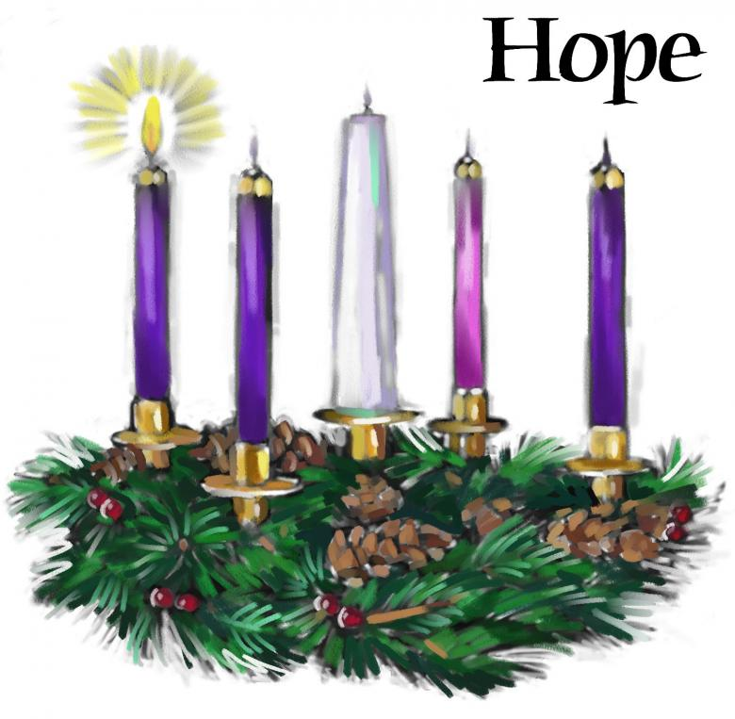

The First Sunday of Advent
Morning Prayer Service

November 28, 2021 at 9:00 am

Andreas Connal-Nicolaou, Officiant
Myra Day, Organist

Join us for In-person worship at St. James Church,
Live on Facebook: St. James Episcopal Church Preston
or on Zoom.

Please join us for fellowship and refreshments in the Parish Hall
following our service.

Morning Prayer

Processional Hymn: #551 Rise Up Ye Saints of God
Morning Prayer

Processional Hymn: #551 Rise Up Ye Saints of God

Morning Prayer

Welcome

The Advent Candle

Reader 1: Today is the first Sunday of Advent. Advent is a time of waiting. We wait for God to send divine love and light into our dark world. Reader 2: How does this happen? Reader 1: God’s light comes through Jesus, who became a human being just like you and me, so that he could show us the way back to God’s divine love and light. Congregation: Almighty God, give us grace to cast away the works of darkness and put on the armor of light. Reader 1: Today, we wait for the coming of Jesus. We begin in the dark, and on this first Lighting the first Advent candle. Reader 2: Every week in the season of Advent, we will light another candle. Each candle that we light will remind us that Christ, the Light of the World, will soon come to us. Congregation: The Kingdom of God is drawing near. May we prepare our hearts with God’s peace, God’s justice, and God’s love. Amen.

Processional Hymn: #56 O Come, O Come, Emmanuel vs. 1 & 2

Officiant: Prepare ye the way of the Lord, make straight in the desert a highway for our God.

Confession of Sin

Officiant: Let us confess our sins against God and our neighbor.

Officiant and People:
Officiant: Grace to you and peace from God.

Confession of Sin

Officiant: Let us confess our sins against God and our neighbor.

Officiant and People:
Morning Prayer

Processional Hymn: #551 Rise Up Ye Saints of God
Officiant: Grace to you and peace from God.

Confession of Sin

Officiant: Let us confess our sins against God and our neighbor.

Officiant and People:
Morning Prayer

Processional Hymn: #551 Rise Up Ye Saints of God
Officiant: Grace to you and peace from God.

Confession of Sin

Officiant: Let us confess our sins against God and our neighbor.

Officiant and People:
Officiant: Grace to you and peace from God.

Confession of Sin

Officiant: Let us confess our sins against God and our neighbor.

Officiant and People:

Most merciful God, we confess that we have sinned against you in thought, word, and deed, by what we have done, and by what we have left undone. We have not loved you with our whole heart; we have not loved our neighbors as ourselves. We are truly sorry and we humbly repent. For the sake of your Son Jesus Christ, have mercy on us and forgive us; that we may delight in your will, and walk in your ways, to the glory of your Name. Amen.

Officiant: Almighty God have mercy on us, forgive us all your sins through our Lord Jesus Christ, strengthen us in all goodness, and by the power of the Holy Spirit keep us in eternal life. Amen.

The Invitatory and Psalter
Officiant: Lord, open our lips.
People: And our mouth shall proclaim your praise.

Officiant & People:
Glory to the Father, and to the Son, and to the Holy Spirit: as it was in the beginning, is now, and will be fore ever. Amen.

Officiant: Our King and Savior now draws near: Come let us adore him.

Psalm 25:1-9
People respond in bold

1 To you, O Lord, I lift up my soul;
my God, I put my trust in you; *
let me not be humiliated,
nor let my enemies triumph over me.
2 Let none who look to you be put to shame; *
let the treacherous be disappointed in their schemes.
3 Show me your ways, O Lord, *
and teach me your paths.
4 Lead me in your truth and teach me, *
for you are the God of my salvation;
in you have I trusted all the day long.
5 Remember, O Lord, your compassion and love, *
for they are from everlasting.
6 Remember not the sins of my youth and my transgressions; *
remember me according to your love
and for the sake of your goodness, O Lord.
7 Gracious and upright is the Lord; *
therefore he teaches sinners in his way.
8 He guides the humble in doing right *
and teaches his way to the lowly.
9 All the paths of the Lord are love and faithfulness *
to those who keep his covenant and his testimonies.

Officiant & People: Glory to the Father, and to the Son, and to the Holy Spirit: as it was in the beginning, is now, and will be for ever. Amen.
The Lessons
Jeremiah 33:14-16
The days are surely coming, says the Lord, when I will fulfill the promise I made to the house of Israel and the house of Judah. In those days and at that time I will cause a righteous Branch to spring up for David; and he shall execute justice and righteousness in the land. In those days Judah will be saved and Jerusalem will live in safety. And this is the name by which it will be called: "The Lord is our righteousness."

Reader: Here ends the Lesson

Canticle 11 The Third Song of Isaiah Surge, illuminare
Isaiah 60:1-3, 11a, 14c, 18-19
Arise, shine, for your light has come, *
and the glory of the Lord has dawned upon you.
For behold, darkness covers the land; *
deep gloom enshrouds the peoples.
But over you the Lord will rise, *
and his glory will appear upon you.
Nations will stream to your light, *
and kings to the brightness of your dawning.
Your gates will always be open; *
by day or night they will never be shut.
They will call you, The City of the Lord, *
The Zion of the Holy One of Israel.
Violence will no more be heard in your land, *
ruin or destruction within your borders.
You will call your walls, Salvation, *
and all your portals, Praise.
The sun will no more be your light by day; *
by night you will not need the brightness of the moon.

The Epistle
1 Thessalonians 3:9-13
How can we thank God enough for you in return for all the joy that we feel before our God because of you? Night and day we pray most earnestly that we may see you face to face and restore whatever is lacking in your faith. Now may our God and Father himself and our Lord Jesus direct our way to you. And may the Lord make you increase and abound in love for one another and for all, just as we abound in love for you. And may he so strengthen your hearts in holiness that you may be blameless before our God and Father at the coming of our Lord Jesus with all his saints.

Reader: Here ends the Lesson

Canticle 16 The Song of Zechariah
Benedictus Dominus Deus

Blessed are you, Lord, the God of Israel, *
you have come to your people and set them free.
You have raised up for us a mighty Savior, *
born of the house of your servant David.
Through your holy prophets you promised of old to save us from our enemies, *
from the hands of all who hate us,
To show mercy to our forebears, *
and to remember your holy covenant.
This was the oath you swore to our father Abraham, *
to set us free from the hands of our enemies,
Free to worship you without fear, *
holy and righteous before you, all the days of our life.
And you, child, shall be called the prophet of the Most High, *
for you will go before the Lord to prepare the way,
To give God’s people knowledge of salvation *
by the forgiveness of their sins.
In the tender compassion of our God *
the dawn from on high shall break upon us,
To shine on those who dwell in darkness and the shadow of death, *
and to guide our feet into the way of peace.

Sequence Hymn: #61 Sleepers, Wake! A voice astounds us

The Lesson from the Gospel
Luke 21:25-36
Jesus said, "There will be signs in the sun, the moon, and the stars, and on the earth distress among nations confused by the roaring of the sea and the waves. People will faint from fear and foreboding of what is coming upon the world, for the powers of the heavens will be shaken. Then they will see 'the Son of Man coming in a cloud' with power and great glory. Now when these things begin to take place, stand up and raise your heads, because your redemption is drawing near." Then he told them a parable: "Look at the fig tree and all the trees; as soon as they sprout leaves you can see for yourselves and know that summer is already near. So also, when you see these things taking place, you know that the kingdom of God is near. Truly I tell you, this generation will not pass away until all things have taken place. Heaven and earth will pass away, but my words will not pass away. "Be on guard so that your hearts are not weighed down with dissipation and drunkenness and the worries of this life, and that day catch you unexpectedly, like a trap. For it will come upon all who live on the face of the whole earth. Be alert at all times, praying that you may have the strength to escape all these things that will take place, and to stand before the Son of Man."

Lector: The Word of the Lord.
People: Thanks be to God.

The Apostles' Creed

I believe in God, the Father almighty,
creator of heaven and earth;
I believe in Jesus Christ, his only Son, our Lord.
He was conceived by the power of the Holy Spirit
and born of the Virgin Mary.
He suffered under Pontius Pilate,
was crucified, died, and was buried.
He descended to the dead.
On the third day he rose again.
He ascended into heaven,
and is seated at the right hand of the Father.
He will come again to judge the living and the dead.
I believe in the Holy Spirit,
the holy catholic Church,
the communion of saints,
the forgiveness of sins
the resurrection of the body,
and the life everlasting. Amen.

The Prayers
Officiant: The Lord be with you.
People: And also with you.
Officiant: Let us pray.

The Lord’s Prayer
Our Father, who art in heaven,
hallowed be thy Name,
thy kingdom come,
thy will be done,
on earth as it is in heaven.
Give us this day our daily bread.
And forgive us our trespasses,
as we forgive those who trespass against us.
And lead us not into temptation,
but deliver us from evil. Amen

Suffrages:

Suffrage B
Officiant: Save your people, Lord, and bless your inheritance;
People: Govern and uphold them, now and always.
Officiant: Day by day we bless you;
People: We praise your Name for ever.
Officiant: Lord, keep us from all sin today;
People: Have mercy on us, Lord, have mercy.
Officiant: Lord, show us your love and mercy;
People: For we put our trust in you.
Officiant: In you, Lord, is our hope;
People: And we shall never hope in vain

The Collect
Almighty God, give us grace to cast away the works of darkness, and put on the armor of light, now in the time of this mortal life in which your Son Jesus Christ came to visit us in great humility; that in the last day, when he shall come again in his glorious majesty to judge both the living and the dead, we may rise to the life immortal; through him who lives and reigns with you and the Holy Spirit, one God, now and for ever. Amen.

The Prayers of the People
Officiant: In quiet anticipation of your coming, O Lord, remind us that you are always with us, that like Joseph we desire to fulfill your will, and we are eager to pray:
O God, in days to come your house will be established, and your joy shall reign. We pray for the church, and especially Grace and St. James, that you might teach us your ways and that we might walk in your paths.
Come Lord Jesus, and hear our prayer.

Out of Zion shall go forth instruction, and you, O God, will judge the nations. We pray for our nation, and all nations, that your justice and peace would be found by every race, gender and class of people throughout the world.
Come Lord Jesus, and hear our prayer.

In your Kingdom, O Lord, wolves lie down with lambs and children play with serpents without fear. We pray for the sick, the suffering, and those in distress of any kind that you would heal all people, comfort everyone in their grief, and bring us to a place to where we can acknowledge our differences and learn from one another.
Come Lord Jesus, and hear our prayer.

In your Kingdom, O Lord, even the wilderness and dry land are glad and rejoice. We pray for those who rejoice this week as they celebrate their birthdays and anniversaries that they might obtain joy and gladness, and sorrow and sighing might flee away.
Come Lord Jesus, and hear our prayer.

In the fullness of time, O God, you sent your son, to be born of our sister Mary. And his name was Emmanuel: God with Us. We thank you for your Presence with us, and we pray that you might be always present with those whom we love but see no longer.
Come Lord Jesus, and hear our prayer.

O Christ, hear our prayers, restore us, and show us the glorious light of your countenance, that we might be reborn in.
Come Lord Jesus. Amen.

The Prayers of the People
Officiant and People:
Almighty God, Father of all mercies, we your unworthy servants give you humble thanks for all your goodness and loving-kindness to us and to all whom you have made. We bless you for our creation, preservation, and all the blessings of this life; but above all for your immeasurable love in the redemption of the world by our Lord Jesus Christ; for the means of grace, and for the hope of glory. And, we pray, give us such an awareness of your mercies, that with truly thankful hearts we may show forth your praise, not only with our lips, but in our lives, by giving up ourselves to your service, and by walking before you in holiness and righteousness all our days; through Jesus Christ our Lord, to whom, with you and the Holy Spirit, be honor and glory throughout all ages. Amen.

Peace
Officiant: The peace of the Lord be always with you.
People: And also with you.
Officiant: Let us bless the Lord.
People: Thanks be to God.

Officiant:
The grace of our Lord Jesus Christ, and the love of God, and the fellowship of the Holy Spirit, be with us all evermore. Amen.

Recessional Hymn: #72 Hark the Glad Sound! The Savior comes

Announcements

Postlude

News & Announcements

St. James 2nd annual Online Christmas Fair will be held on November 21st through December 5th. This year vendors that will be participating are: Scentsy, Pampered Chef, Quilt Patch Unlimited, Boon Supply, Tastefully Simple, Jewelly’s Cards, Kettlepot and Butter Braids & Cookies! So do a little Christmas shopping in the comfort and safety of your home while supporting our church and its ministries. To order go to the follow website at: www.stjamespreston.org/online-christmas-fair Thank you for your support!

Grace Episcopal Church, 4 Chapel Hill Rd, Yantic will be having a Holiday Craft and Vendor Fair with Luncheon on Saturday December 4th from 9:00 am to 2:00 pm., with craft vendors, Christmas decorations, pottery, homemade canning items, candles and more. Their Take-Out Only Luncheon starts at 11:00 to 1:00 pm with includes Deb’s Corn Chowder or homemade tomato soup, choice of sandwiches: Chicken salad, egg salad or grilled cheese and apple crisp all for $8.00. You can call ahead at 860-887-2082.

Owl Luncheon at St. James Church Thursday December 9 at Noon. Christmas Ham dinner will be served. Please RSVP by calling the church office at 860-889-0150.

The Preston Public Library, Route 2, Preston will be hosting a fun holiday workshop. Participants will make a decorative tree and wreath ornament. Refreshments will be available. There is a $15 supply fee. To register please call 860-886-1010 or by email: prestonlibraryprograms@gmail.com

The Fitchville Home Christmas Visit will be Sunday December 19 at 1:00 pm. This year they will be able to go inside with masks on as all residents are vaccinated. They are looking for carolers, musicians and if anyone has a Santa suit and would like to play Santa. Please contact Terry Gardner at 860-889-2314 for more information.

St. James’ Greening of the Church immediately following worship services on December 19th. Come join the fun and be amazed at how beautiful our church looks when we are done!
All wanting to help are welcome.

Scripture & Compline: Thursdays, 7pm via Zoom
Guided Healing Prayers: Fridays, 8am via Zoom

In case of a church emergency or have pastoral needs, please contact
the church office.

